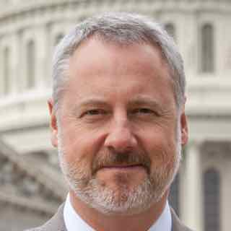
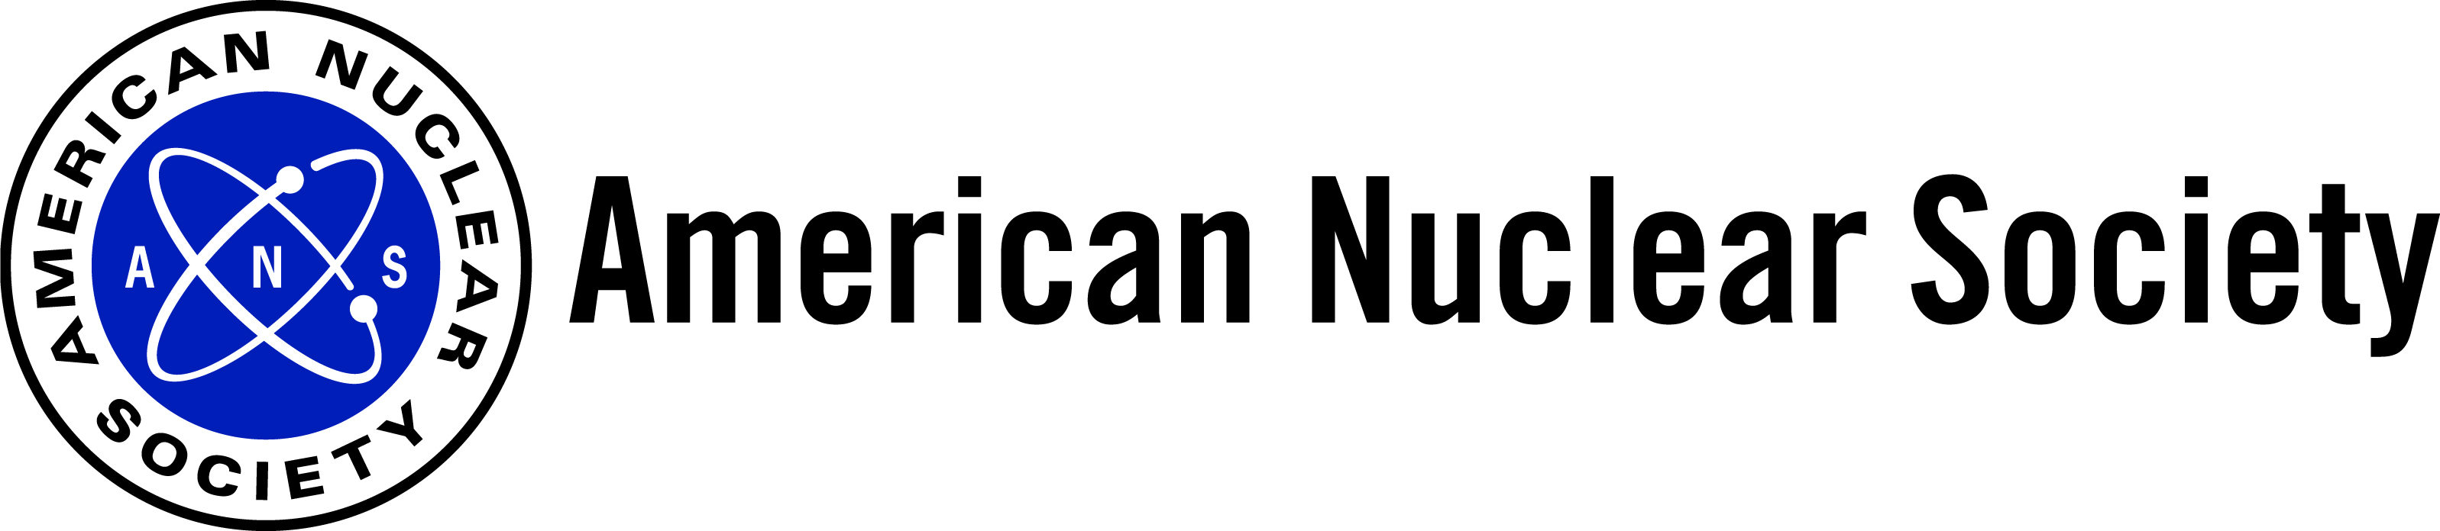

Craig Piercy
Washington Representative

Craig serves as the Washington Representative for the American Nuclear Society, where he helps devise and execute ANS federal outreach activities to Capitol Hill and the Executive Branch on behalf of the 11,000 men and women of the American nuclear community. Since assuming his role in 2005, Craig has played a central role in several high-profile nuclear issues, including the creation of the Nuclear Energy University Program (NEUP) and Integrated University Program (IUP), and defeating legislation that would have banned the commercial use of 14 radioisotopes.
Prior to entering private practice, Craig worked on Capitol Hill for 8 years, serving as Chief of Staff for Congressman Joe Knollenberg (R-MI) and Associate Staff of the House Appropriations Committee. During his time on Capitol Hill, Craig worked on important nuclear issues, including the preservation of federal nuclear R&D funding and the accelerated cleanup of DOE nuclear sites. Craig also served as Assistant Vice President of Federal Affairs for Wayne State University where he coordinated several successful, high-profile political efforts to secure funding for WSU’s R&D activities.
Craig also serves on the U.S. Department of Commerce Civil Nuclear Trade Advisory Committee (CINTAC) and sits on the Board of Directors of the Public Affairs Council. In 2011, he received an ANS Presidential Citation for his role in ANS post-Fukushima response communications and public engagement efforts.
Craig has a bachelor’s degree in Government and Politics from the University of Maryland, College Park and is a graduate of the Public Affairs Institute. He lives in Bethesda, MD with his wife Clare and their two children and is an avid skier, canoeist, and Formula One fan.

