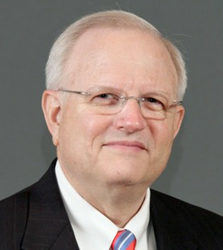

Sigval (Sig) M. Berg is currently the Executive Director of The Severn Leadership Group in Annapolis, Maryland. Additionally, he served as a mentor and lecturer (leadership development) at the World Nuclear University’s Summer Institute at Oxford England from 2009 -2013.

Mr. Berg has also served in a number of senior executive positions in the nuclear industry. Mr. Berg was the Senior Vice President for Infrastructure Development and Training at UniStar Nuclear Energy (a joint venture of Constellation Energy and EDF -- developing the EPR for the US) in Baltimore, Maryland. (2007-2008)

Prior to that, Mr. Berg was an executive at the Institute of Nuclear Power Operations (INPO) in Atlanta, Georgia from 1994-2006. As executive vice president, he was responsible for INPO’s Evaluation and Assistance cornerstones. From 2002 to 2004 he served as managing director of the World Association of Nuclear Operators (WANO) in London, England. Additional responsibilities during his time at INPO included serving as executive vice president for the Accreditation cornerstone and the Administrative Division, executive director of the National Academy for Nuclear Training, director of the WANO–Atlanta Center and deputy director of the WANO-Coordinating Center in London, Mr. Berg was elected executive vice president of INPO in April 2000, senior vice president in March 1998, and vice president in February 1996.

Mr. Berg joined INPO in 1994 after three years with Commonwealth Edison in Chicago, Illinois where he served as site vice president, Braidwood Nuclear Station (PWR); technical superintendent, Dresden Nuclear Station (BWR); assistant to production superintendent, Dresden Nuclear Station; and nuclear administrator, office of the vice president, PWR operations. During this time he completed Executive Senior Reactor Operator Training (BWR).

A 1968 graduate of the U.S. Naval Academy, he served in the U.S. Navy until 1981 holding several positions in the Navy nuclear program, including the position of chief engineer of a nuclear-powered submarine. In November 1998, Mr. Berg completed the Harvard Graduate School of Business’ Advanced Management Program and has a MDIV from Trinity Lutheran Seminary in Columbus, Ohio (1981).

